Beverage | Cup/Mug/glassware | Cutlery | Accompaniments
Beverage | Cup/Mug/glassware | Cutlery | Brown sugar | White sugar | Milk | Cream | Lemon | Honey | Choc powder | Cinnamon
Filter coffee | 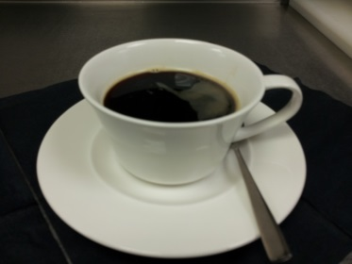 | Coffee spoon | X | X | X | X
Espresso | 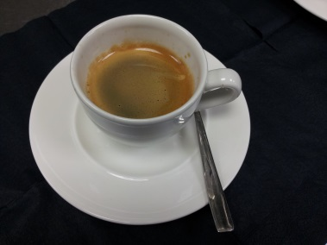 | Coffee spoon | X | X
Cappuccino  An Italian coffee traditionally prepared with espresso, hot milk and steamed-milk foam | 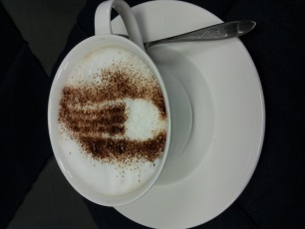 | Coffee spoon | X | X |  |  |  |  | X | X
Latte  A coffee made with espresso and steamed milk | 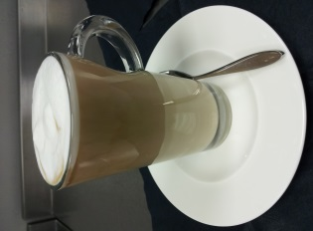 | Latte spoon | X | X
Americano  A coffee made with espresso and topped with hot water | 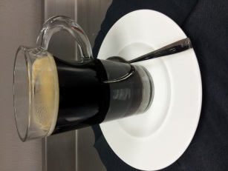 | Coffee spoon | X | X
Mocha  A coffee made with espresso and hot chocolate, combined with hot steamed milk | 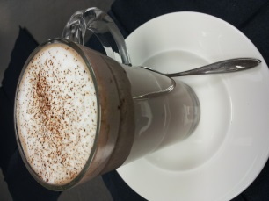 | Coffee spoon |  | X |  |  |  |  | X
Hot chocolate  Hot steamed milk or water, or a combination of both mixed with hot chocolate powder or chocolate sticks | 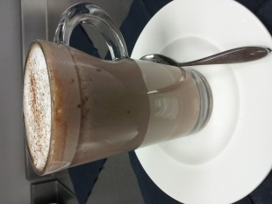 | Latte spoon |  | X |  |  |  |  | X
Tea  Hot water combined with any number of flavoured tea leaves or bags, may be served on its own, with milk, lemon or honey to the consumers taste | 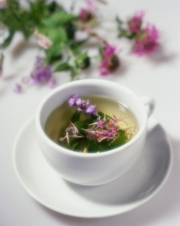 | Tea spoon |  | X |  |  | X | X

